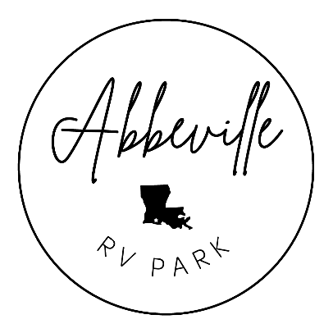
WELCOME TO ABBEVILLE RV PARK

We’re delighted to welcome you to Abbeville RV Park! Before we dive into the rules, please note that rent is due upon arrival. A $5.00 per day late fee (1 PM to 5 PM) will be charged for late payments. Now, let’s ensure everyone has a wonderful stay by following these rules:
1. RENT PAYMENT: Rent is to be paid in advance upon your arrival.
2. PETS: We love pets, but owners are entirely responsible and liable for them. Pets can’t be left
unattended and must be on a leash when outside your RV. Walk your pets on designated areas and clean up after them promptly. Noisy pets won’t be allowed to stay, and aggressive breeds are not permitted.
3. CAMPFIRES: Campfires are allowed in designated fire rings only and must be attended at all
times. Keep a pail of water nearby. Do not use fire rings for disposal.
4. GARBAGE: Please bag your garbage and deposit it in the dumpsters. Only household-generated
garbage is permitted in dumpsters. Take broken furniture, grills, rugs, tires, appliances, etc.,
with you. Keep our park clean—no littering, including cigarette butts.
5. SPEED LIMIT: Please drive at a maximum speed of 5 MPH within the park. Always observe one-
way signs.
6. QUIET HOURS: From 10:00 PM to 8:00 AM, let’s keep the noise down. This is essential for
everyone’s relaxation. Radios and TVs should be at minimum volume settings, and normal
speaking voices can carry, so be mindful. Ensure your children stay at your site during quiet
hours.
7. VISITORS: Inform the Host camper if you’re expecting visitors. Non-camping guests must leave
between 10:00 PM and 8:00 AM during quiet hours. You are responsible for ensuring your guests
comply. Visitor parking is at the nature trail head, with a $1.00 per guest charge. It’s your duty to
collect and pay this fee to the camp host before leaving the park.
8. NO FIREARMS OR FIREWORKS: Firearms, BB Guns, Fireworks, Sling-Shots, and Bow & Arrows
are not allowed in the park.
9. NATURE TRAIL: No bicycles, ATVs, or motorized vehicles are allowed on the nature trail. ATVs
are not allowed on park property.
10. KEEP THE PARK TIDY: No clotheslines or other lines tied to trees. Do not leave appliances or
unsightly items outdoors. Window units are not allowed.
11. NO TENTS: Tents are not allowed in the park.
12. BEHAVE RESPECTFULLY: Any unruly, lewd, unreasonably loud behavior, or failure to obey these
rules may result in permanent removal from the park property. The manager reserves the right
to refuse service.
ENJOY YOUR STAY!
Thank you for choosing Abbeville RV Park. We hope you have a fantastic stay with us. If you have a moment, please consider liking us on Facebook and leaving a review on Facebook or Google. Your feedback is greatly appreciated!

